GITHUB-LINK:

<https://github.com/khizarkhawaja5/Acs213050-khizar>

POST REQUEST:

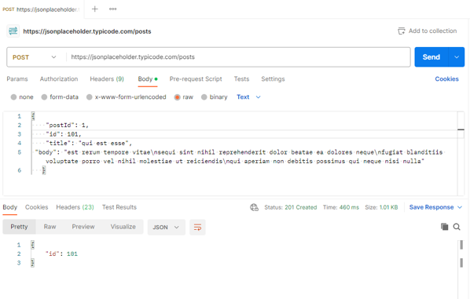

DELETE REQUEST:

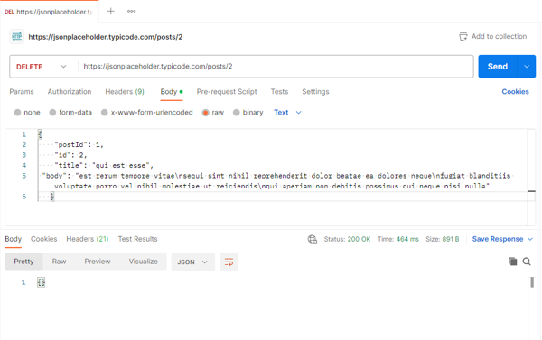

PUT REQUEST:

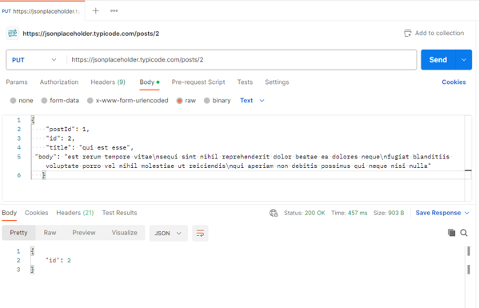

GET REQUEST:

